WEST LONDON WASTE AUTHORITY

AUDIT COMMITTEE
Report of the Treasurer | 23 June 2023
Draft Statement of Accounts for the year ending 31 March 2023

SUMMARY
This report presents the draft 2022/23 Statement of Accounts
RECOMMENDATION(S)
The Authority is asked to:-
- Note the Draft Statement of Accounts for 2022/23 (Appendix 1)
- Approve the disbursement of PPP contract income totalling £12.7 million (section 13)
- Approve the disbursement of excess reserves totalling £3.3 million (section 24)
Introduction
- The draft 2022/23 accounts were produced as usual in April and were ready for audit by EY, our external auditors from May. EY’s audit work yet to commence as they have just finalised their audit work on 2021/22 accounts.

- A summary of the draft statement of accounts is provided below. It should be noted that at the end of April 2022, the auditors had requested for an updated IAS19 report in relation to pensions for 2021/22. This was due to the triennial valuations taking place after March 2022 and the audit standard ISA540 requiring further information to see whether the revaluation may indicate a material difference or error.

Due to this request, and the Pension providers finalising an updated FY22 report, there has been a delay in the 2022/23 pension scheme valuation, and these figures have not been included in the draft accounts.

Statement of Accounts
- The Statement of Accounts can be found in Appendix 1. The key sections of the draft accounts are explained below:

- Narrative Statement (page 2) – This section provides background about the Authority’s operations. It also summarises the financial position and performance for the year.

- Statement of Responsibilities for the Statement of Accounts (page 9) - This is a brief statement outlining the Authority’s requirements in relation to the Accounts and the role and responsibility of the Treasurer, principally to ensure the accounts present a true and fair view
of the Authority’s finances. This is where the Treasurer certifies the Statement of Accounts and the Chair signs them on behalf of the Authority.

- Comprehensive Income and Expenditure Statement (page 11) – This is a core financial statement. It shows the financial performance during the year. The operating performance is highlighted in the surplus on provision of services of £5.587 million. We are awaiting the pension valuation to verify if there is a gain or loss on the pension liability, so as it stands, there is a total comprehensive income and expenditure of £5.587 million.

- Balance Sheet (page 13) – This is another core financial statement. It shows the financial position or strength of the Authority at the end of the year. The overall picture of the balance sheet is strong with a positive net worth of £77.133 million. Continuing the healthy trend, this means the Authority has more assets than liabilities.

- Notes to the Core Financial Statements (pages 16-45) – these provide details, breakdown and analyses in accordance with various disclosure requirements for most of the items identified in the above 2 core statements.

- Accounting Policies (page 17) – This section explains the Authority’s key accounting policies. These are long standing and pretty much standard local authority accounting policies which are used in maintaining records and producing the financial statements

- Annual Governance Statement (page 46) – This is a key statement within the Accounts that outlines the Authority’s view of the effectiveness of its governance and internal control framework. The statement identifies the Authority’s duties and lists the main elements of the corporate governance framework most of which are reported to Authority meetings during the year.

- Independent Auditors Report (page 49) – This provides our external auditor’s opinion and confirms the accounts present a true and fair view of the Authority’s finances. The opinion will be per their report and the statement will be updated for the latest EY template once they complete their work.

Provisional out-turn 2022/23
- The financial performance during 2022/23 is provided in the table below and compares the actual performance to the budgeted level in a more familiar budget monitoring format which groups spends in an operational way.
Financial Performance 2022/23 | Budget £000s | Actual £000s | Variance £000s
Expenditure
Employees | 2,648 | 2,640 | (8)
Premises | 2,672 | 2,479 | (193)
Waste, Transport and Disposal | 49,558 | 45,128 | (4,430)
MRF Waste Transport and Disposal | 2,148 | 2,705 | 557
Other supplies | 1,198 | 1,673 | (474)
Depreciation | 9,809 | 10,465 | 655
Financing | 6,067 | 5,589 | (478)
Concession Adjustment | (4,473) | (4,473) | 0
 | 69,628 | 65,606 | (3,423)
Income
Levies | (64,552) | (62,654) | 1,898
MRF Service Charge | (2,148) | (2,705) | (557)
Trade and Other | (2,128) | (3,594) | (1,466)
 | (68,828) | (68,953) | (125)
(Surplus) on provision of services | 800 | (3,347) | (3,548)
HRRC Fund | 1,200 | 265 | (935)
PPP Contract Income | (2,000) | (19,094) | (17,094)
PPP Contract Income Disbursed | 0 | 12,729 | 12,729
FY22 Excess Reserves to Boroughs | 0 | 3,261 | 3,261
Net (Surplus) / Deficit | 0 | (5,587) | (5,587)
Actuarial gain on pension liability | 0 | 0 | 0
Property valuation gains | 0 | 0 | 0
Contribution to reserves | 0 | (5,587) | (5,587)

- The operational performance above delivered a surplus of £5.6 million. The major component of this (£19.1 million) relates to the Authority’s share of income generated by the energy from waste plant (PPP income), principally electricity income. Two thirds of this (£12.7 million) will be passed through to boroughs in accordance with our Finance Strategy as agreed with Boroughs Directors. The other notable operational variance as reported in previous months relates to lower volumes of waste arising during the year and contributing towards a significant favourable variance of £4.43 million.

Post draft account production adjustments
- As mentioned previously, the pension valuations for 2022/23 have not yet been received and the figures have not been included in the statement of accounts.

- These adjustments will be applied to the final accounts and EY will naturally audit these post draft account production changes and refer to them in their final report.

Strategic Perspective
- To provide context and a better strategic perspective, it helps to look at the financial performance over a period of time. Therefore, below the chart “Total WLWA cost per tonne” looks at how effectively the Authority has managed its costs. The total cost of delivering services (including disposal and treatment costs of all waste materials, overheads and financing but excluding PPP income and valuation adjustments) is divided by the total tonnes of waste (all materials) disposed by the Authority, to provide an overall cost per tonne figure. This has been plotted over a longer timeframe.

- The key feature illustrated by this chart is that the Authority’s operating cost per tonne is 11.86% more than it was in 2016/17. Over the same period cumulative inflation amounted to 39.42%. Whilst there is a small increase year on year, the chart reflects the continuous operational efficiencies the Authority makes whilst delivering on their services. It is worth noting that 2016/17 included significant one off benefits resulting from the commencement of full service at the new energy recovery centre.
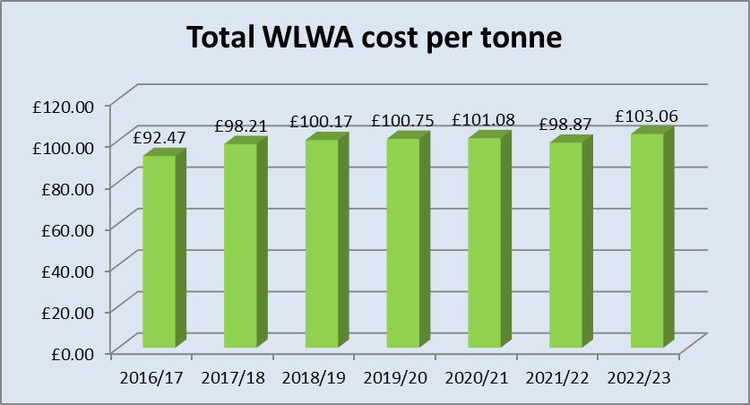

- It is also useful to consider how the operational performance (i.e. surplus / deficit on provision of services) has moved over the same period of time. This is illustrated in the chart below which shows that the Authority has ensured that sufficient funds are being generated from day to day activities to meet day to day obligations.
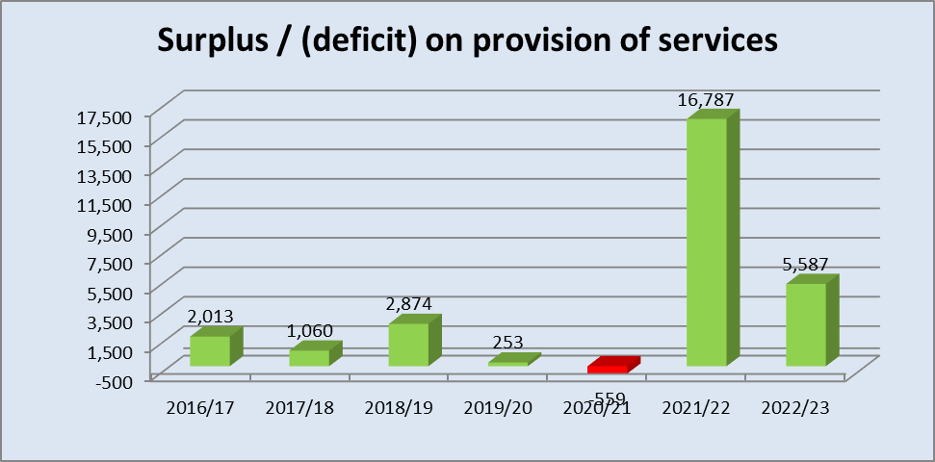

- Both of the charts above show that from strategic longer term perspective and also from the individual year’s results, the financial performance has been good.

- As well as performance, it is also important to consider the financial strength of the Authority. A good indicator of financial strength is the level of reserves. The table below outlines the change in the Authority’s reserve position during the year.
Reserves
Reserves b/f |  | 71,546
Contribution to reserves |  | 5,587
Reserves c/f |  | 77,133

- However, property valuation gains are notional and a result of valuation exercises. Furthermore as proposed in the draft Finance Strategy two thirds of the additional income from the PPP contract will be passed through to boroughs and one third will be retained by the Authority for strategic projects. Also the investment made to Boroughs in 2022/23 for HRRC Improvements has not been fully utilised, and the balance has been earmarked from reserves to be disbursed in 2023/24. Therefore by excluding these we have a more realistic picture of the level of reserves available to the Authority for managing risks.
Reserves |  | 77,133
Exclude property revaluation gains |  | (52,732)
PPP income retained by WLWA from FY22 and FY23 |  | (9,917)
HRRC funding to be spent in FY24 |  | (935)
Reserves available to manage risks |  | 13,550

- Once again, by considering reserves available to manage risk over a longer timeframe, provides a more strategic perspective. The following chart plots these over the same period applying the new income sharing arrangements within the draft Finance Strategy to the latest year.
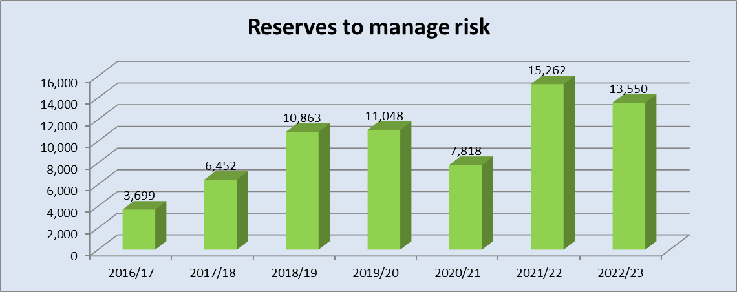

- The chart above shows that the Authority has improved its position by building its reserves as the basis of a financial buffer to better manage unexpected risks. This cautious approach reflects the changing legislative requirements and operating environment.

Excess reserves

- The 2023/24 budget highlighted that £10.3 million was needed to manage risks. At the end of 2022/23 they totalled £13.6 million. This means there are excess reserves of £3.3 million.

- Therefore as done annually, the Authority will disburse back the excess reserve amount of £3.3 million to boroughs. This will be apportioned using the council tax base as in previous years and will appear as a rebate of levies in the 2023/24 budget monitoring reports and accounts. Note that the Authority’s forecasts of spending and levies will show an under-recovery of £3.3 million in 2023/24 to reflect this disbursement.

Disbursement to boroughs
- The boroughs share of PPP income plus the excess reserves will be paid to boroughs by the end of July following receipt of sums from the contractor. The table below provides a breakdown of the payments.
Borough | Approved Council Tax Base | PPP Income (£000s) | Excess Reserves at end of 2022/23 (£000s) | Total payments to boroughs (£000s)
Brent | 101,187 | 2,163 | 562 | 2,725
Ealing | 121,613 | 2,600 | 676 | 3,275
Harrow | 89,085 | 1,904 | 495 | 2,399
Hillingdon | 103,625 | 2,215 | 576 | 2,791
Hounslow | 89,309 | 1,909 | 496 | 2,405
Richmond | 89,289 | 1,909 | 496 | 2,405
Total | 594,108 | 12,700 | 3,300 | 16,000

Year-end valuations
- The latest pension valuation by the LPFA’s actuaries have not yet been provided as the auditors (EY) had requested FY22’s valuations to be calculated again post the triennial valuation. This has resulted in a delay from LPFA for FY23.
30. Financial Implications – These are detailed in the report.

31. Legal Implications – It is a statutory requirement for the Authority to produce annual financial statements.

Contact Officers | Jay Patel, Finance Director 01895 54 55 10  jaypatel@westlondonwaste.gov.uk  Ian O’Donnell, Treasurer  ianodonnell@westlondonwaste.gov.uk  Sapna Dhanani, Finance Manager  sapnadhanani@westlondonwaste.gov.uk

